**Name:** Ruizhe Zhang

**Batch code:** LISUM10: 30 May - 30 Aug 2022

**Submission date:** 06/14/2022

**Submitted to:** Canvas (GitHub URL)

**Step 1:** Data Choosing

In order to understand how to use Flask better, I select the dataset showing NBA players’ points, rebounds, assists and salary (shown in the files as “NBA.csv”), trying to predict NBA player’s salary based on his performance:

**Step 2:** Saving the model using model.py (code shown below)

**Step 3:** Changing data type and prediction_text in app.py

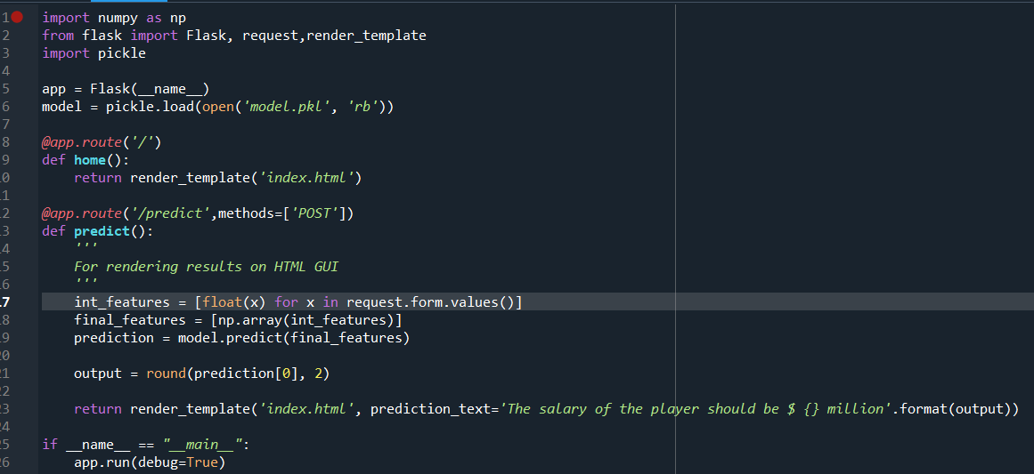

**Step 4:** Making changes to the HTML template (index.html)

(Only the title and placeholders were changed in order to prevent unexpected errors)

**Step 5:** Deploying the model on flask

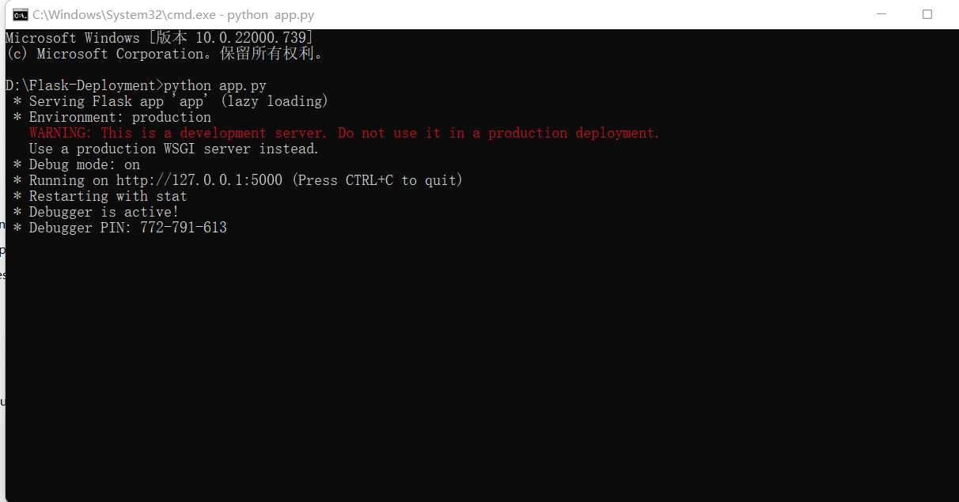

**Step 6:** Opening the running app and type in random data to predict:



